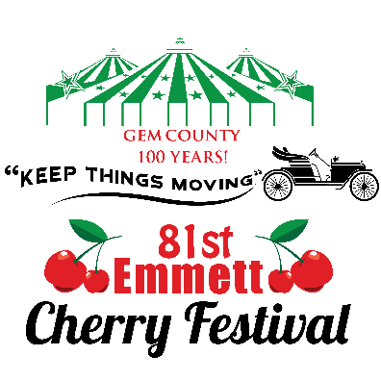

81st Annual Emmett Cherry Festival
June 17-20, 2015
Emmett City Park, Emmett, ID

The Gem County Chamber of Commerce is a 501(c) 6, membership non-profit organization who promotes Emmett and Gem County. This is one of the Chamber’s fundraisers, promoting our community as well as our members, and businesses throughout the Treasure Valley.
Since the 1930s, the community of Emmett and all of Gem County has gathered each June to celebrate the abundance of our valley. We celebrate with the region’s longest continually running festival, “The Emmett Cherry Festival.”
The Emmett Cherry Festival is always held during the second full week of June. The traditional Cherry Festival events, concerts and carnival all happen in the Emmett City Park starting on Wednesday and running through Saturday. Other celebrations and events take place throughout the community during the week of the Emmett Cherry Festival.
Families gather, friends reunite and over 50,000 folks get together over the four days for the greatest family-friendly event in Idaho!
Of the many, many things that set the Emmett Cherry Festival apart from other events, most notably is the abundance of FREE and FAMILY-FRIENDLY activities.
Some of the many free activities include:
- No cost to enter, no admission or gate fees
- Free daily entertainment and nightly concerts
- Parade and children’s parade
- Free entry in to all contests
- And, of course, the fun is always Free For All

